Name : Aditya Kachwaha
Roll No. : 14
PRN No. : 12413066
Assignment: 1
The Problem-Solving Life Cycle and Its Applications
1. The Problem-Solving Life Cycle
The problem-solving life cycle offers a structured method for tackling problems. It generally encompasses these stages:
- Problem Definition: Clearly state the problem, taking into account any limitations and the intended outcome.
- Problem Analysis: Investigate the problem thoroughly, examining it from various perspectives to pinpoint the crucial elements.
- Solution Generation: Develop a range of potential solutions, initially without evaluating their practicality.
- Solution Evaluation: Assess each possible solution based on its practicality, effectiveness, required resources, and potential risks.
- Solution Selection: Choose the solution that most effectively satisfies the criteria and constraints established in the earlier stages.
- Solution Implementation: Put the chosen solution into action.
- Review and Assessment: Evaluate the implemented solution's effectiveness and make necessary adjustments.
2. Application to Problem 1: The River Crossing Puzzle
Problem Statement:
A man needs to transport a goat, a tiger, and a bundle of grass across a river. His boat can only carry two items at a time, and he is the only one who can row. How can he successfully get everyone and everything to the other side?
Applying the Problem-Solving Life Cycle:
- Problem Definition:
  - Goal: Successfully move the goat, tiger, man, and grass to the opposite riverbank.
  - Constraints:
    - The boat's capacity is limited to two passengers.
    - The man must be the one operating the boat.
    - The goat and tiger cannot be left unsupervised.
    - The goat and grass cannot be left unsupervised.
- Problem Analysis:
  - The challenge lies in determining the sequence of boat trips while adhering to the given restrictions.
  - Only the man can row the boat.
  - The state of both riverbanks must be considered after each crossing.
- Solution Generation:
  - This problem necessitates exploring various combinations of passengers and cargo for each trip.
- Solution Evaluation:
  - Each potential trip must be checked against the problem's constraints.
- Solution Selection:
  - Algorithm:
    - The man takes the goat to the other side.
    - The man returns to the original side alone.
    - The man takes the tiger to the other side.
    - The man brings the goat back to the original side.
    - The man takes the grass to the other side.
    - The man returns alone.
    - The man takes the goat to the other side.
- Solution Implementation:
  - The algorithm outlines the steps for carrying out the solution.
- Review and Assessment:
  - The algorithm ensures all constraints are met and that the transfer is completed successfully.
3. Application to Problem 2: The Temple Flowers
Problem Statement:
A boy visits four temples near a pond, with a flower plant nearby. Before entering each temple, he picks a flower and bathes in the pond. The pond's unique property is that it doubles the number of flowers a person carries each time they take a dip. The boy offers the same number of flowers at the first three temples and leaves the third temple with no flowers. How many flowers did the boy offer at each temple?
Applying the Problem-Solving Life Cycle:
- Problem Definition:
  - Goal: Determine the quantity of flowers the boy presented at each of the three temples.
  - Constraints:
    - The boy starts with one flower.
    - Dipping in the pond doubles the flower count.
    - An equal number of flowers are offered at each temple.
    - The boy has no flowers left after the third offering.
- Problem Analysis:
  - This problem requires reverse calculation, starting from the final condition of zero flowers.
  - The flower count changes predictably: doubling after a dip and decreasing by a fixed amount after each offering.
- Solution Generation:
  - Algebraic equations or a backward-working method can be employed to find the solution.
- Solution Evaluation:
  - Let 'x' represent the number of flowers offered at each temple.
    - After the 3rd offering: 0 flowers
    - Before offering: x flowers.
    - Before the 3rd dip: x/2 flowers.
    - After the 2nd offering: x/2 flowers.
    - Before offering: x/2 + x = 3x/2
    - Before the 2nd dip: 3x/4
    - After the 1st offering: 3x/4.
    - Before offering 3x/4 + x = 7x/4
    - Before the 1st dip: 7x/8
    - Initially: 7x/8 = 1
    - Solving for x, we get x = 8/7.
- Solution Selection:
  - x = 8/7
- Solution Implementation:
  - The boy offered 8/7 flowers at each temple.
- Review and Assessment:
  - The solution aligns with all the problem's conditions.
  - Algorithm:
    - Start with 1 flower.
    - Temple 1:
      - Dip in the pond (double flowers).
      - Offer 'x' flowers.
    - Temple 2:
      - Dip in the pond (double flowers).
      - Offer 'x' flowers.
    - Temple 3:
      - Dip in the pond (double flowers).
      - Offer 'x' flowers.
    - The boy has 0 flowers remaining.
    - Solve the equation 8 - 7x = 0 to find x = 8/7.

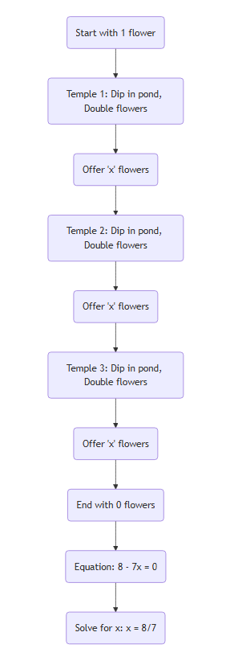
Flowchart 1: Flowchart 2:
